**Module 8**

**Assignment 1**

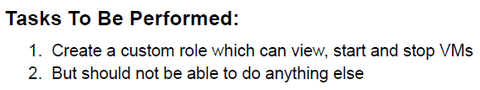

1. To create a custom role, I was facing issue with access to the free trail of Microsoft Entra ID P2. Hence, I am dropping below the steps and not the screenshots.
2. Create a Custom Role
   1. Go to the Azure Portal (https://portal.azure.com/).
   2. In the left-hand menu, click on "Azure Entra ID”
   3. Under "Azure Entra ID," click on "Roles and administrators."
   4. In the "Roles and administrators" section, click on "+ Add custom role."
3. Provide a name for custom role (e.g., VM Operator).
4. In the "Assignable Resources" section, select "Virtual Machines."
5. In the "Permissions" section, click on "Add permissions."
6. Add the following permissions:
   1. Microsoft.Compute/virtualMachines/read (Read virtual machines)
   2. Microsoft.Compute/virtualMachines/start/action (Start virtual machines)
   3. Microsoft.Compute/virtualMachines/deallocate/action (Stop/Deallocate virtual machines)
7. Click "Review + create" to move to the next step. Custom Role would be created.
8. Assign the Custom Role to a User or Group
9. After creating the custom role, go to "Azure Entra ID " > "Roles and administrators."
   1. Select the custom role created (e.g., VM Operator).
   2. Click on "Add assignments."
   3. Choose the user or group that we want to assign this role to.
   4. Click on "Add assignments" to save the assignment.
10. In the Azure Portal, navigate to "Virtual machines."
11. Verify that the user/group can view the list of virtual machines.
12. Select a virtual machine, and check if the user/group can start and stop the virtual machine.

**Assignment 2**

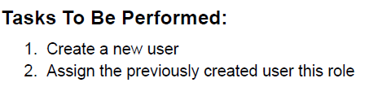

1. In the Azure Portal, go to "Azure Entra ID."
2. Under "Manage," click on "Users." Click on "+ New user."
3. Fill in the user details:
   1. User name: Provide a unique username.
   2. Name: First and last name of the user.
   3. User type: Choose "New user in your organization."
   4. Role: Leave it as "User."
   5. Usage location: Choose an appropriate location.
4. Assign the user to a group if needed (optional).
5. Click "Create" to create the new user.
6. In the Azure Portal, go to "Azure Entra ID."
7. Under "Manage," click on "Roles and administrators."
8. Select the custom role we previously created (e.g., VM Operator).
9. Click on "Add assignments."
10. Choose the newly created user from the list.
11. Click "Add assignments" to save the assignment.
12. Have the new user log in to the Azure Portal using the credentials we provided during user creation.
13. In the Azure Portal, navigate to "Virtual machines."
14. Verify that the user can view the list of virtual machines.
15. Select a virtual machine and check if the user can start and stop the virtual machine.

**Assignment 3**

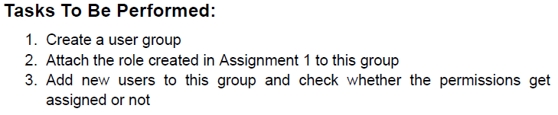

1. In the Azure Portal, go to "Azure Entra ID."
2. Under "Manage," click on "Groups." Click on "+ New group."
3. Choose the group type (e.g., Security).
4. Fill in the required details:
   1. Group name: Provide a unique name.
   2. Membership type: Choose "Assigned."
5. In the Azure Portal, go to "Azure Entra ID."
6. Under "Manage," click on "Roles and administrators."
7. Select the custom role created in Assignment 1 (e.g., VM Operator).
8. Click on "Add assignments."
9. Choose the group we created in Step 1.
10. Click "Add assignments" to save the assignment.
11. In the Azure Portal, go to "Azure Entra ID."
12. Under "Manage," click on "Roles and administrators."
13. Select the custom role we created in Assignment 1 (e.g., VM Operator).
14. Click on "Add assignments."
15. Choose the group we created in Step 1.
16. Click "Add assignments" to save the assignment.
17. In the Azure Portal, go to "Azure Entra ID."
18. Under "Manage," click on "Roles and administrators."
19. Select the custom role you created in Assignment 1 (e.g., VM Operator).
20. Click on "Add assignments."
21. Choose the group we created in Step 1.
22. Click "Add assignments" to save the assignment.